CSL China Compliance for Log360 Cloud
Protect critical infrastructure and meet CSL China compliance with Log360 .
Region: China | Type: Critical Infrastructure | Category: Compliance | Pricing: Free

Overview
The CSL China compliance extension in Log360 helps organizations meet the Cybersecurity Law of the People's Republic of China (CSL), enacted in 2017 by the Standing Committee of the National People's Congress by providing centralized log management, network security monitoring, and compliance-focused reporting. The platform supports CSL China requirements for multi-level protection, access control, audit log retention, personal information protection, and critical information infrastructure security across cloud and on-premise environments.
For Art. 21 — Network Security Level Protection System, Log360 monitors security policies, system configurations, and GPO changes across all network tiers to demonstrate compliance with China's level-based protection requirements. To address Art. 21/24 — Access Control & Identity Authentication, the platform tracks logon events, failed authentications, MFA status, and terminal sessions across AD, Windows, Unix, and network devices to detect unauthorized access attempts. The extension also supports Art. 25 — Network Security Incident Response by providing capabilities that provides real-time threat detection from antivirus, firewall, and network sources, enabling rapid incident identification, investigation, and evidence-based response procedures.

Key Features
- Art. 21 — Audit Log Retention & Monitoring: Log360 collects and retains comprehensive audit logs from Windows, Active Directory, applications, and databases to support the mandated log retention period.
- Art. 21 — Data Classification & Protection: Log360 monitors file changes, removable storage activities, registry modifications, and backup operations to detect unauthorized access, modification, or exfiltration of classified data assets.
- Art. 40-44 — Personal Information Protection: Log360 monitors user account management, identity lifecycle events, and group membership changes across AD and Entra ID to provide audit evidence of authorized personal data processing.
- Art. 31-39 — Critical Information Infrastructure Protection: Log360 monitors network security policies, firewall configurations, and device rules to verify that CII protection controls are properly maintained.

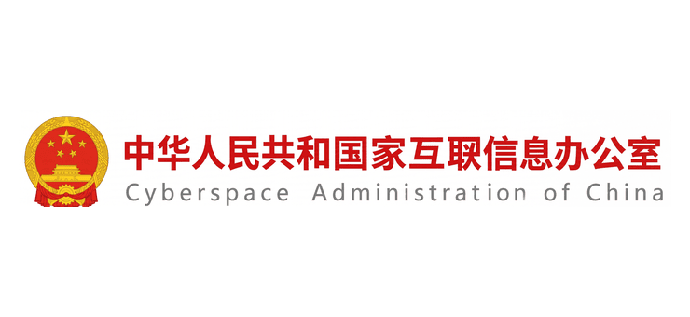
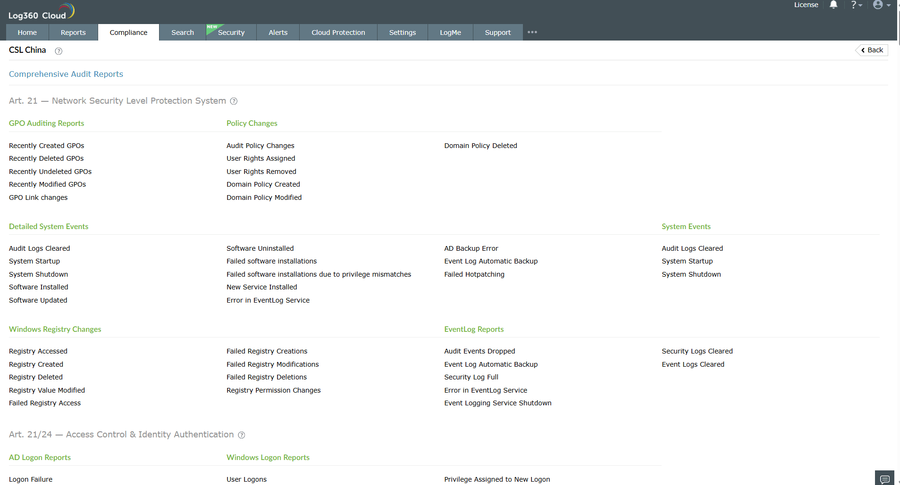
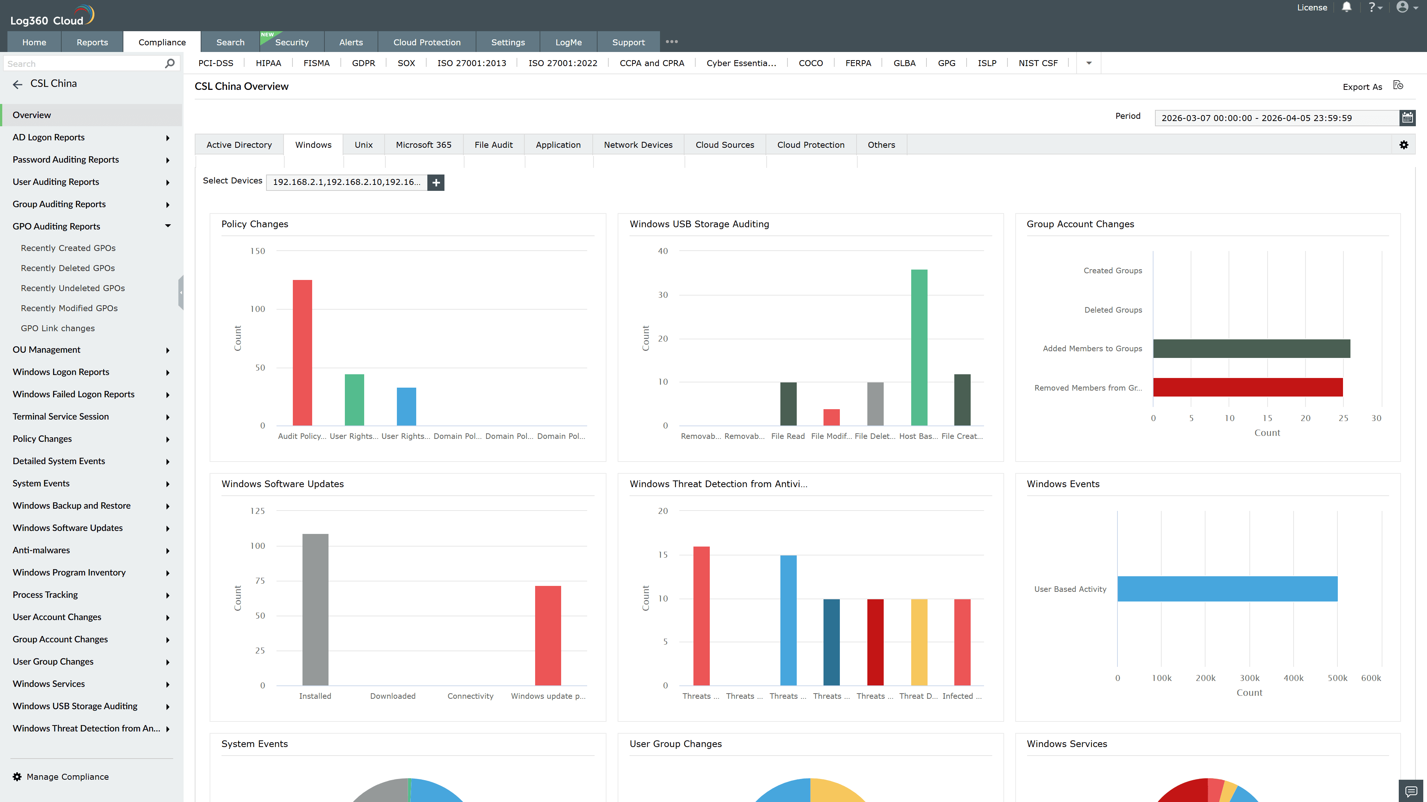
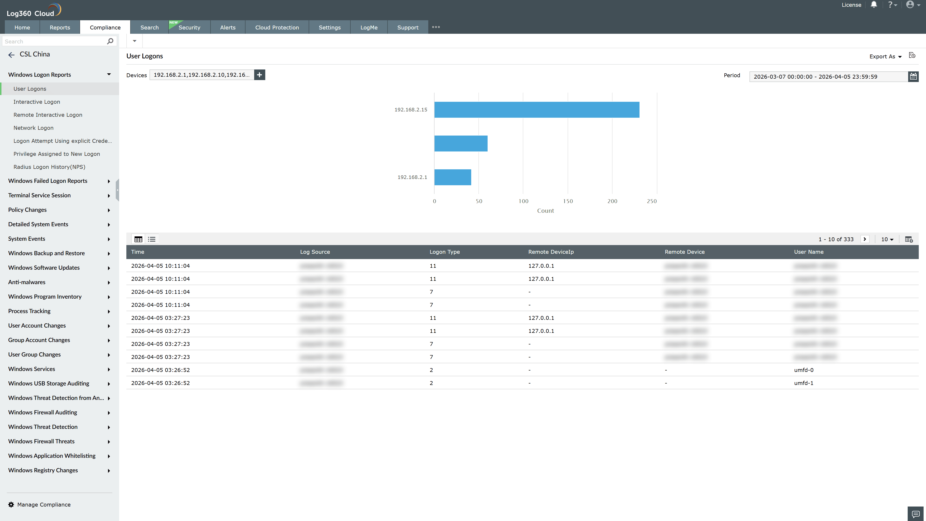
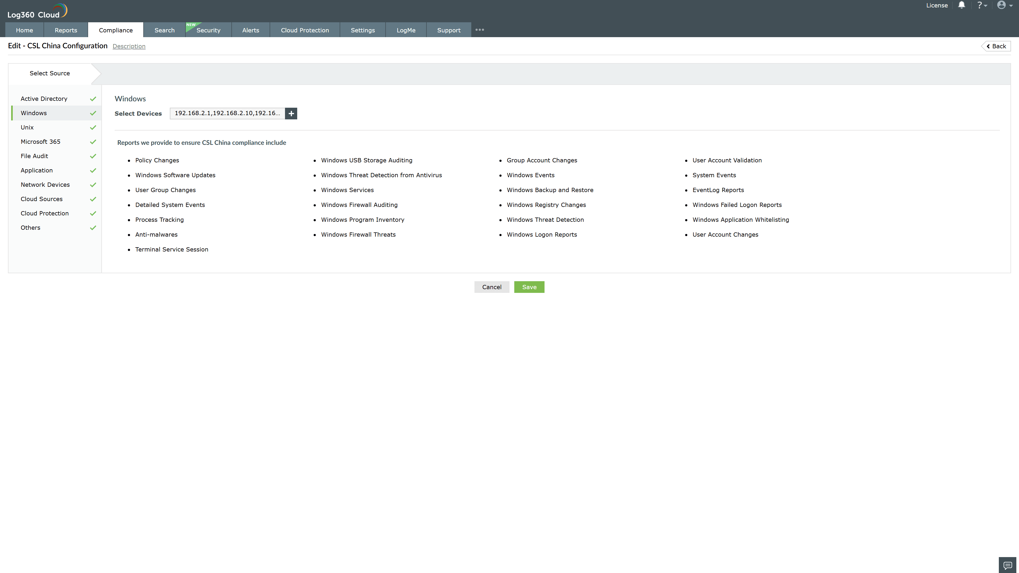
Valid Submission : Yes
Supported Editions : Free, Basic, Standard, Professional, MSSP
Help Document : https://www.manageengine.com/log-management/help/integrations/compliance-extensions.html
Help Video : Not provided
Tags : Log360, Compliance, Privacy monitoring, Data privacy, Regulatory compliance
Supported DCs : US, IN, JP, CA, AU, UK and EU
Privacy Policy:
Terms of Service:
Release Notes:
Predefined reports for the CSL China.

